Fall Flavors - Fact Sheet

Locations 1691 Broadway (between 53rd and 54th Streets)
New York, NY 10019

507 Third Ave @ 34th Street
New York, NY 10022

Phone (855) 444-3388

Website http://piefacenyc.com

Twitter @PieFaceUSA

Facebook Facebook.com/PieFaceUSA

Hours 24 hours a day, 7 days a week

Cuisine Australian meat pies, coffee, sandwiches, baked goods

Fall Menu Specials Thanksgiving turkey pie $5.88
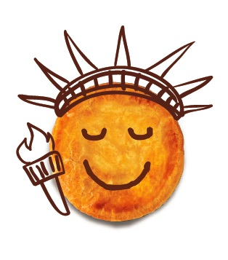
Mini turkey pie $2.66
Roast turkey and stuffing

Thanksgiving “stack” $7.90
Turkey & stuffing pie, topped with mashed sweet potatoes and cranberry sauce

Family-sized sweet pies $24.95
Available in store and to pre-order by phone: 855-444-3388
Apple, Coconut Custard, Pecan, Pumpkin

Mini sweet pies $3.25
Lemon, chocolate mousse, blueberry, cherry, apple crumble, pecan, pear ricotta, key lime, pumpkin, flourless chocolate cake, and cheesecake
6 pack mini sweet pies $16.95
12 pack mini sweet pies $30.95

Description PieFace was founded in Sydney in 2003 by Wayne Homschek and Betty Fong, former fashion designers. Pie Face is a retail bakery café chain specializing in gourmet Australian meat pies (with faces piped on to indicate the filling), sausage rolls, coffee, mini sweet pies, and other baked goods. Pie Face’s Wake Me Up! Coffees provide quality espresso coffee in various strengths to allow customers to order coffee just the way they like it. Pie Face has 75 locations in Australia and its first international store opened in NYC in January 2012. Its second U.S. location, in Manhattan’s Murray Hill neighborhood, opened in September 2012.

